CS457 HW #1

ER Diagram Symbols and Cardinality Constraints

1. Example Attributes
   1. Multi-valued

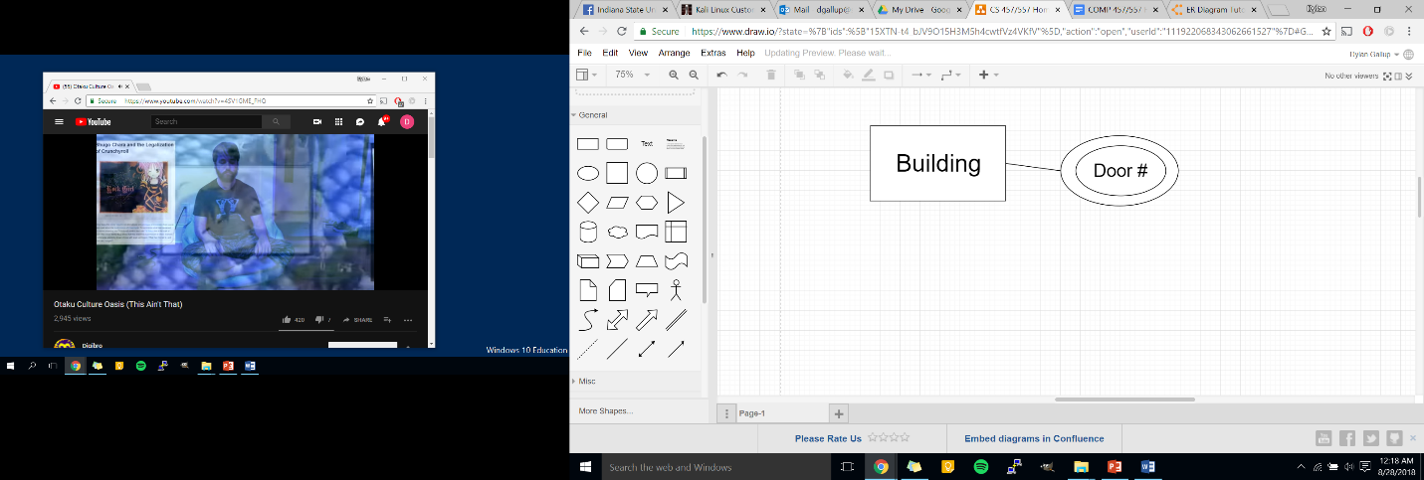

* 1. 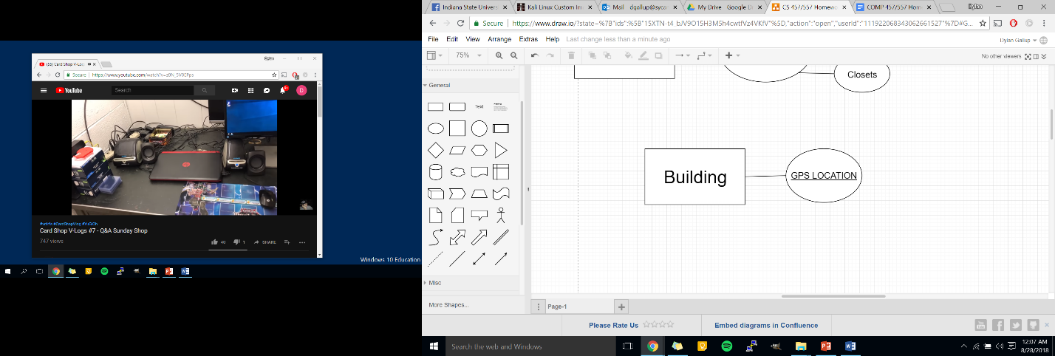Unique/Key
  2. Composite

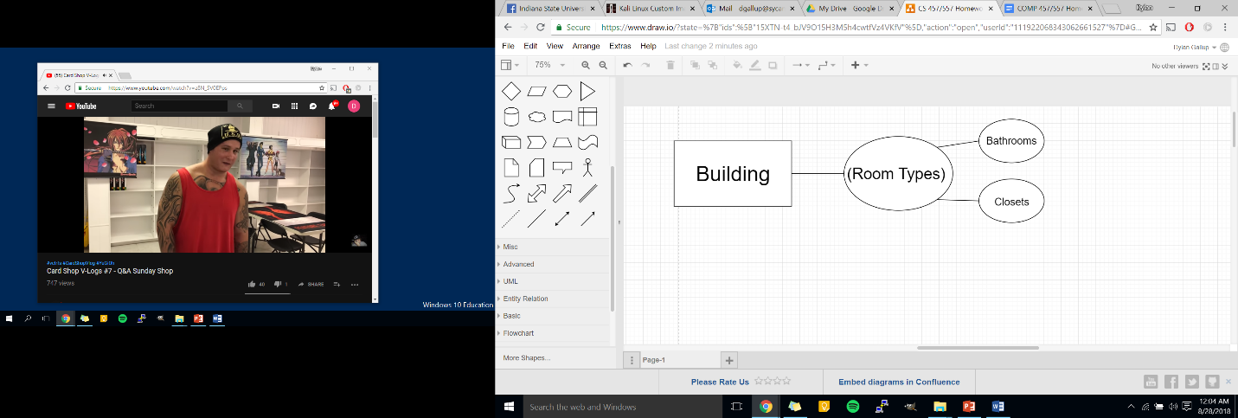

* 1. Derived

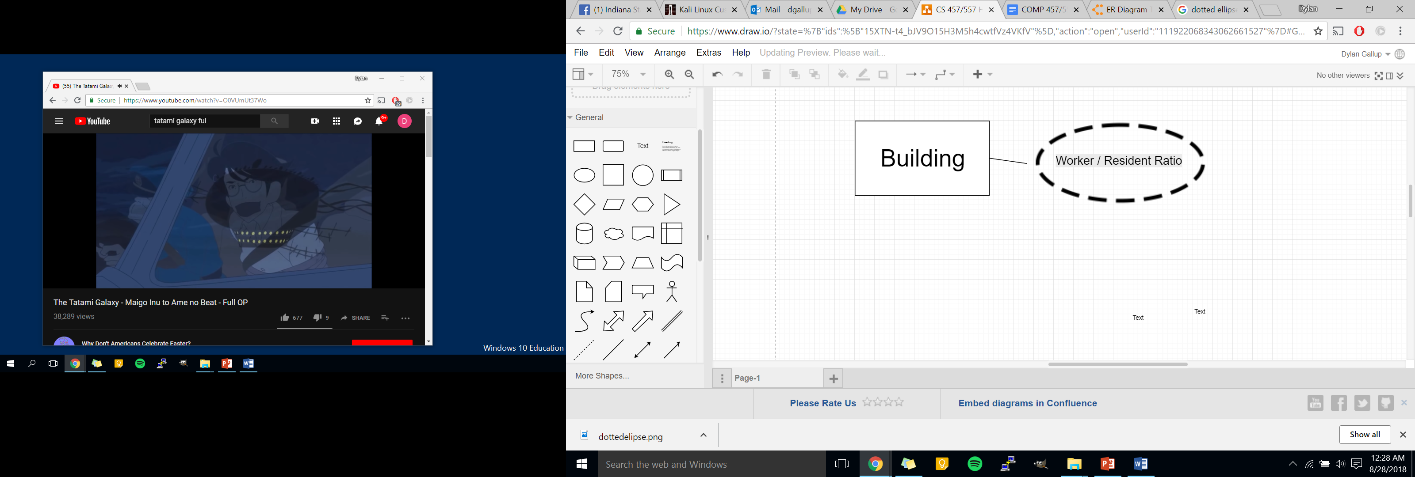

Relations and Cardinality Constraints

* 1. Building and Rooms

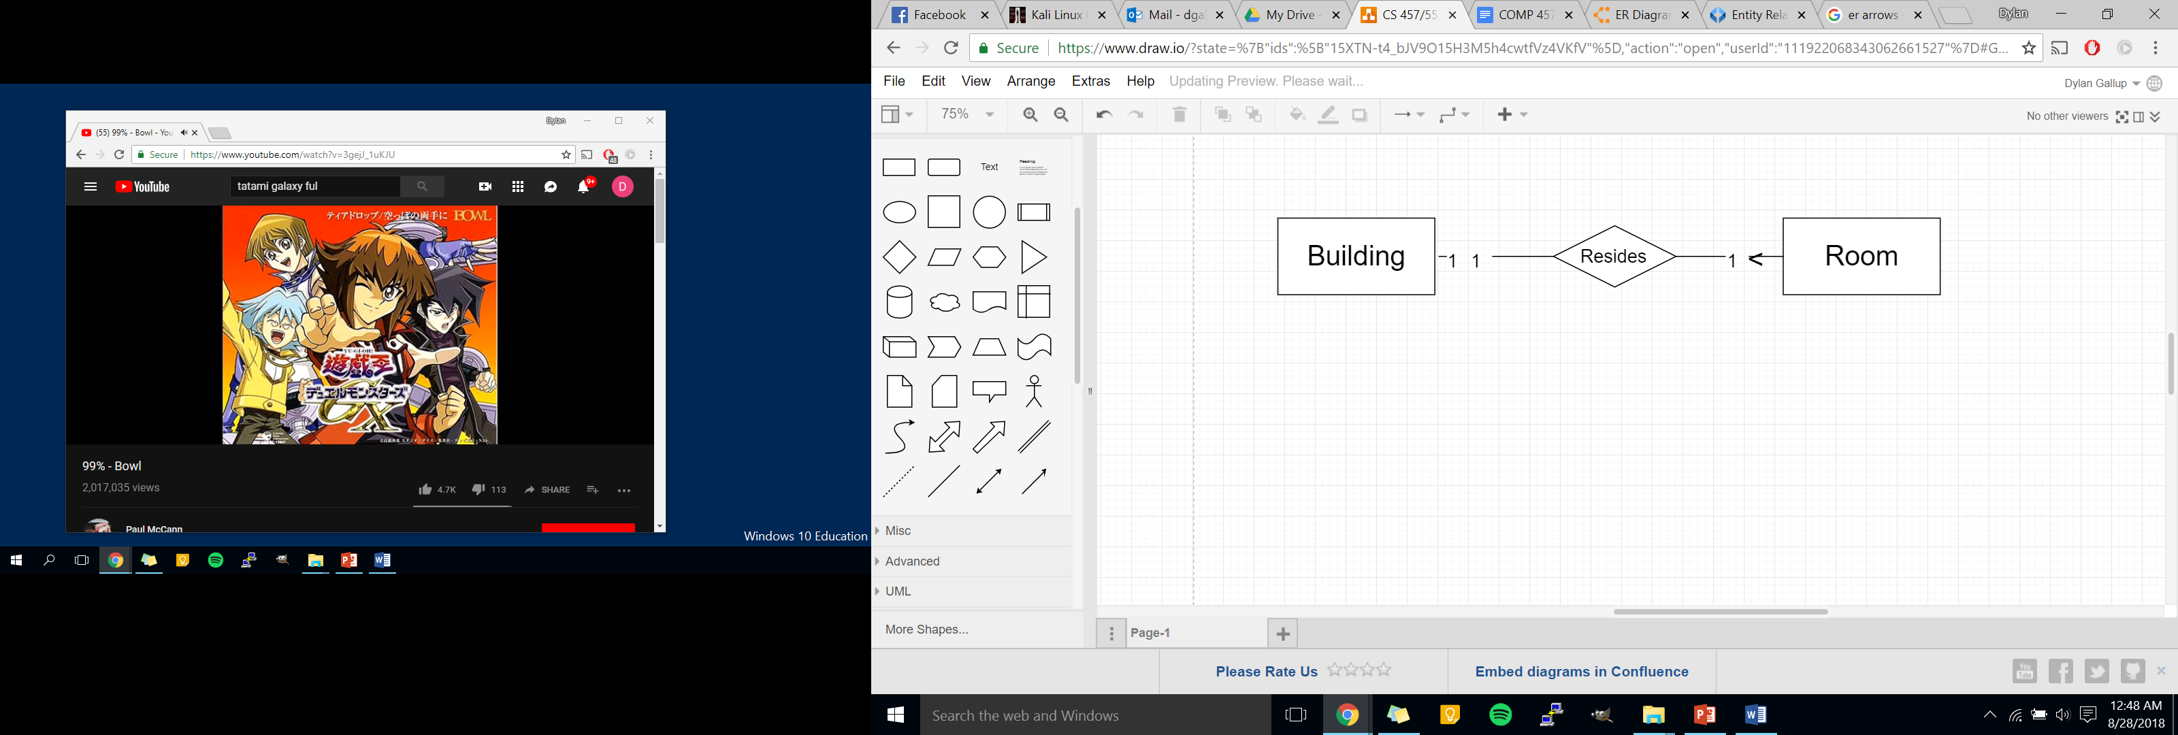

* 1. Departments and Employees

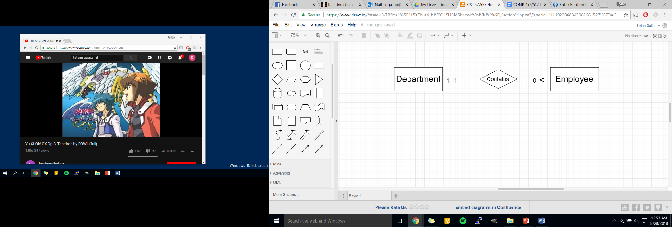

* 1. 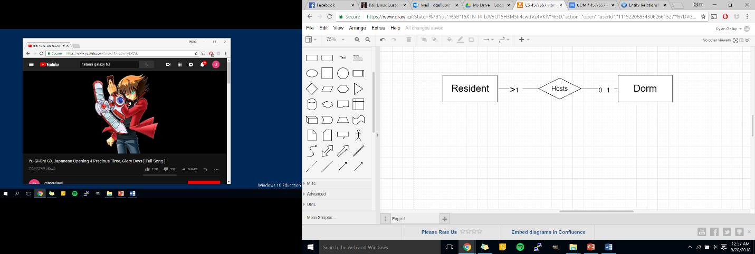Dorms and RA